The_London_Bridge_Solution_Documentation
Written by: Yuval Quina
I started this CTF by performing a Nmap tcp open ports and services scan over the target machine:
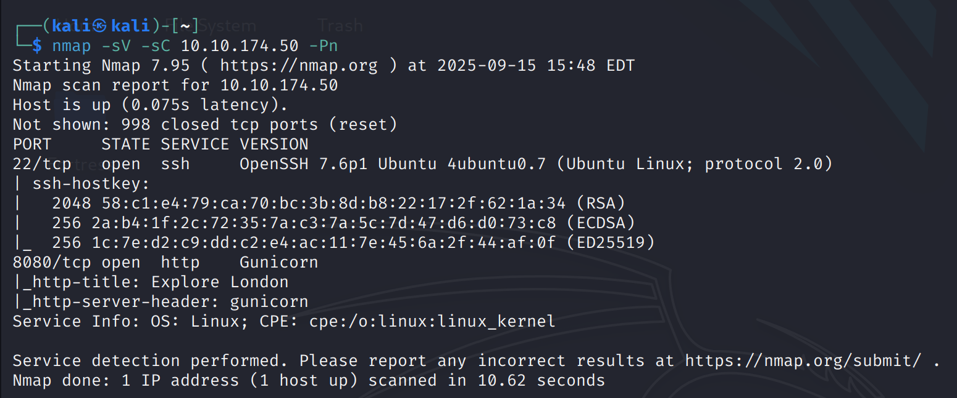
I saw that port 8080 is open, so I accessed the target’s website via the browser:
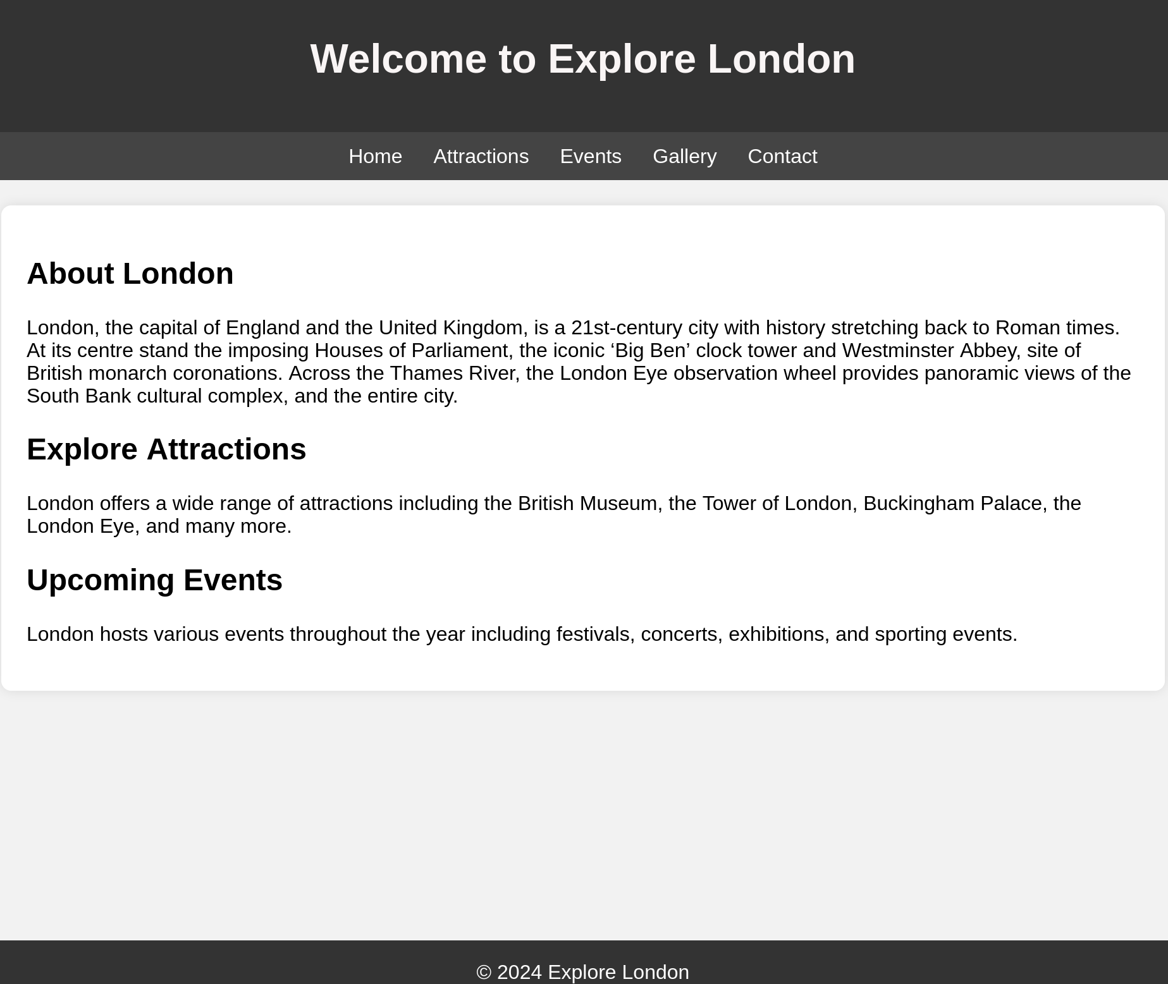
I checked the inspector as well as the robots.txt and found nothing.
I checked the pages and found this page at the “Gallery” section:
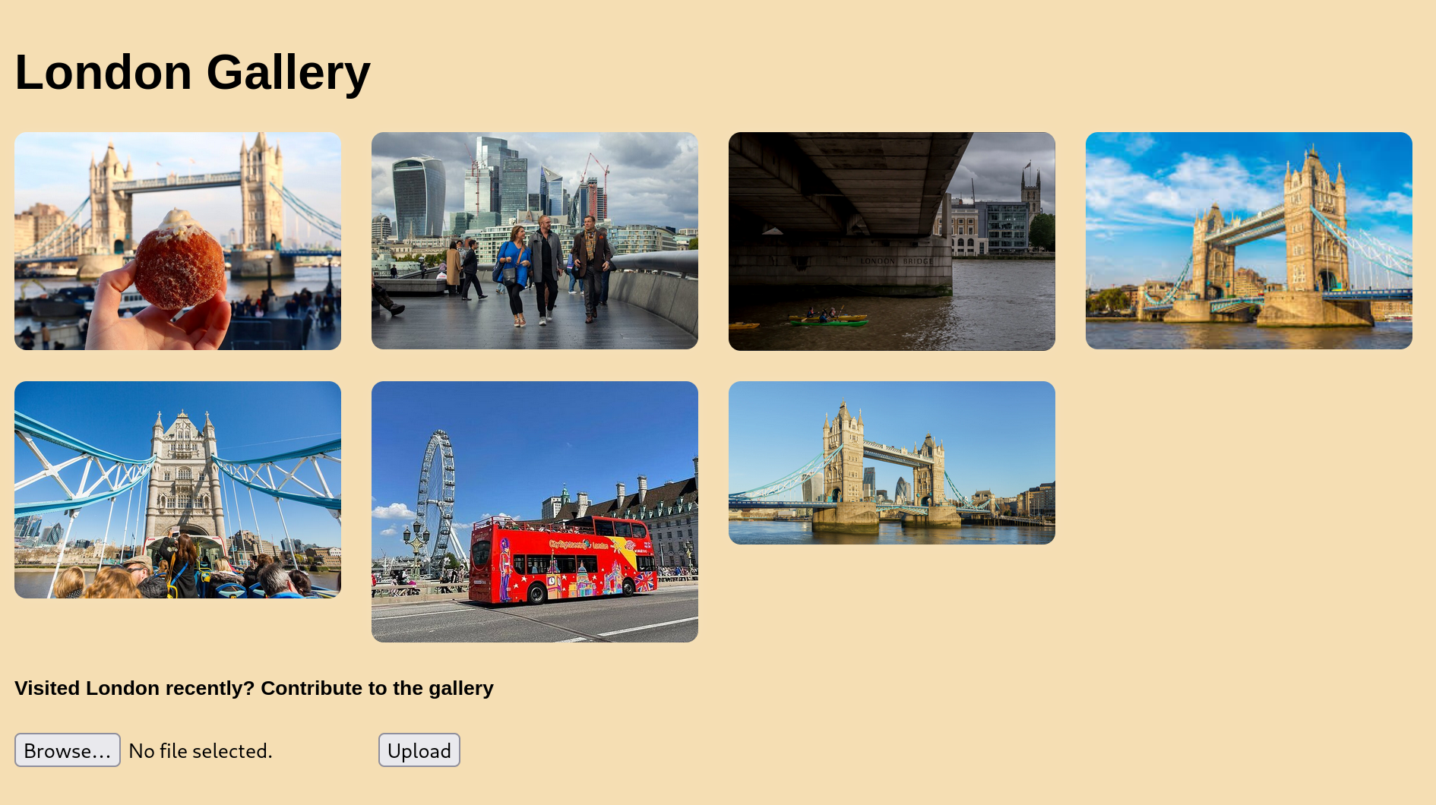
At this point, I tried to upload this rev shell php file:
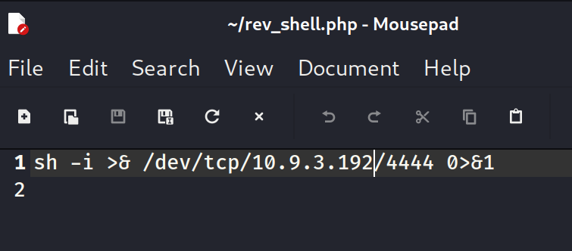
But it failed according to this message:
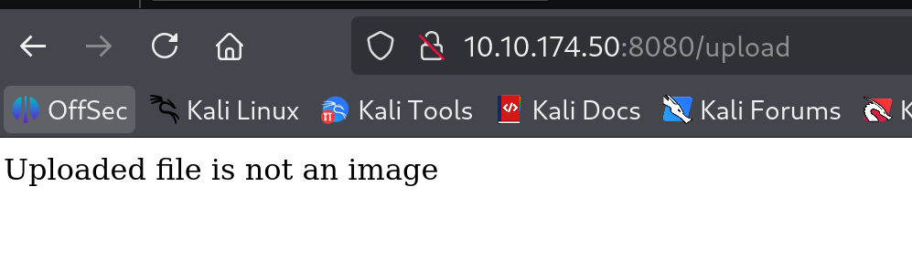
After this fail, I opened the inspector and found this message:
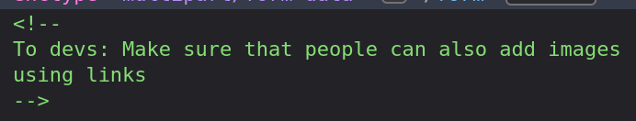
Now, I knew that I can somehow upload images (including the rev shell file) using links in some way.

